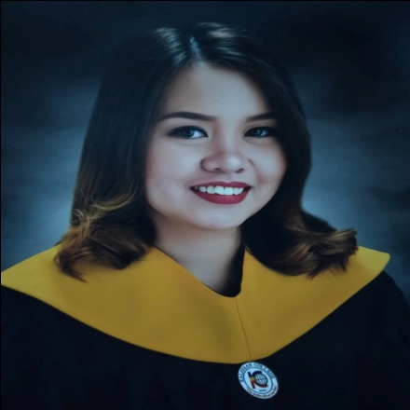**ARLENE Z. BISMONTE**

193 J. Cabral St. Poblacion 1, Calatagan, Batangas

Contact No.: 09298954174

E-mail: bismontearlene@gmail.com

To obtain a position that best suits my qualification, to apply my knowledge and skills, and to serve the company in the best possible way with full determination and commitment.

**WORK EXPERIENCE**

Student Assistant Kalayaan College 2015-2019

Intern TV Patrol ABS-CBN October 2018- March 2019

**EDUCATION**

Kalayaan College 2015 - 2019

Bachelor of Arts in Journalism

Cum Laude

Calatagan National High School 2010-2014

Fifth Honorable Mention

Jacobo Zobel Elementary School 2005 - 2010

Second Honorable Mention

**Skills**

* **Technical:** Computer literate
* Well-oriented in Microsoft Office Applications such as:

- Microsoft Office Word

- Microsoft Office PowerPoint

- Microsoft Office Excel

* Good English communication expertise
* Researching
* Writing

**SEMINARS/TRAININGS ATTENDED**

* [Jaime V. Ongpin Journalism Seminar](http://cmfr-phil.org/excellence-and-best-practices-in-journalism/jaime-v-ongpin-journalism-seminar/seminar/)
* ”Let’s get Real on Fake News” by Philippine Press Institute
* Covering Marawi: Stories from the War Zone forum at Ateneo De Manila University
* 3rd Angelicum Media Congress: Youth and Media

**Personal Background**

Age: 22 years old Citizenship: Filipino

Gender: Female Height: 4 ft 11 inches

Marital Status: Single Weight: 45 kg

**Character References**

Dr. Bella M. Villanueva Professor 09753622341

Kalayaan College

Floyd Christopher T. Villaruel Sales Manager 09361073228

AMA Group of Companies

Genaldo L. Soriano High School Teacher 09989509655

Calatagan National High School

***I hereby certify that the statement I made are complete, true and correct to the best of my knowledge and belief.***

**ARLENE Z. BISMONTE**

Signature of Applicant