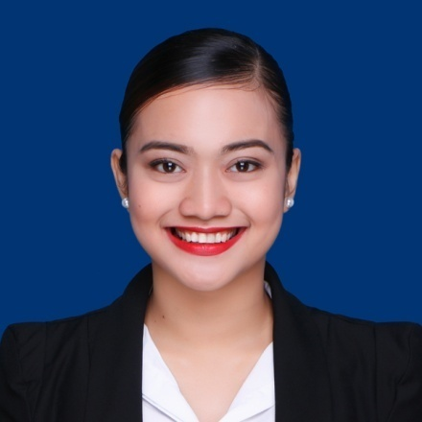

**PROFESSIONAL EXPERIENCE**

Company: ***AIRSWIFT Inc.,*** (Nov. 2016- Present)

Position: ***Flight Attendant- Senior/Lead Cabin Crew***

Contact Number: +63 (2) 318 5900

**EDUCATIONAL ATTAINMENT**

***TERTIARY-*** ***BACHELOR OF SCIENCE IN NURSING***

**UNIVERSITY OF SAN AGUSTIN**

General Luna St, Iloilo City (June 2011 - April 2016)

**SEMINARS/TRAININGS ATTENDED**

**Aug 15, 2016- Sep 6, 2016 Flight Attendant Training Program**

PTC- MILCOM Aviation Training Center Inc.

**Yearly Recurrent Training:** First Aid, Survival, Fire Fighting

**CHARACTER REFERENCE**

Available upon request

**OTHER INFORMATION**

AIDA 2 Licensed Freediver, part- time Freedive Instructor

**MARIEL ANNE Y. FERNANDEZ**

57 Don Carlos Revilla Street Brgy 148 Zone16 Pasay City

***+63 956 488 9392***

[***anneyanezz@gmail.com***](mailto:anneyanezz@gmail.com)

**Date of Birth:** March 1, 1995 **Place of Birth:** IloIlo City, Ph

**Gender:** Female **Civil Status:** Single

**Nationality:** Filipino **Ht:** 5’4 **Wt:** 55kg

***Good Day!***

I am ***Mariel Anne Y. Fernandez***, 25 years old a Filipino citizen. I’ve been in Aviation Industry for four years since 2016 up to present and with my stay, I have gained a lot of knowledge and skills in all aspects that helped me grow not just an in-flight safety crew but as an individual. It has been a desire for me to move to a different step on my career.

I am a flexible person which can easily adapt to different fields, situations and able to cope up well. I am always open for learning new things and willing to be trained.

I am interested to be part of the team to whichever position I am suited to.

Hoping for a positive response.

Sincerely yours,

***FERNANDEZ, MARIEL ANNE Y.***

[**anneyanezz@gmail.com**](mailto:anneyanezz@gmail.com)

**+63 956 488 9392**