**JENIELYN R. GOROSPE** 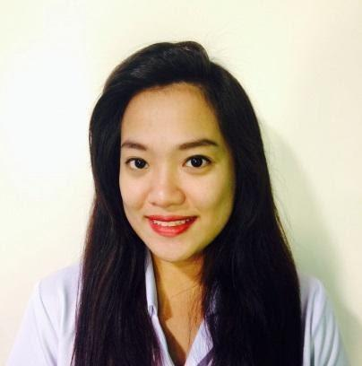

# ***Address:*** *2136 Onyx Street Santa Ana, Manila*

*Contact No. :* 09770221911 / 09695613880 (GLOBE & SMART)

*E-mail Address: jenielyngorospe8@gmail.com*

***PROFILE:***

* Proven ability to communicate effectively with people of various ages, race, and cultural background through experience.
* Enthusiastic, outgoing attitude.
* Computer literate and keenly interested in developing a career in the IT industry.

***SKILLS AND COMPETENCIES:***

* Highly adaptable, patient risk-taker who is open for new ideas
* Can be cinematographer in a team
* Basic knowledge in editing video software
* Trained in handling, and ministering difficult clients.
* Can handle difficult clients.
* Flexible when it comes to work and to my co-worker.
* Extremely productive in a high volume, high stress, environment.
* Advance computer skills and working knowledge in Microsoft Office
* Self-starter with a can do attitude.
* Excellent interpersonal skills and a great team player/leader.
* Energetic and has a positive outlook, which often inspires others.

***INTERNSHIPS EXPERIENCE:***

## ***Department of Agriculture, Internship***

* Encoding and transcribing files
* managing the documents
* doing an admin ass. Work

## ***Assistant Photo Booth Operator 2015***

* Philippine Photo Booth Organization, Internship
* Picking up the booth then arriving at the event at least one hour prior to its start time.
* Set up the booth which includes lifting equipment, connecting cables as instructed, preparing props or a scrapbook, and running several tests on the functionality of the booth

***RELEVANT WORK EXPERIENCE****:*

* **Assistant Wedding Photographer and Assistant Videographer and Assistant Wedding Coordinator 2015 – 2018**
  + - Determine desired images and picture composition; and select and adjust subjects, equipment, and lighting to achieve desired effects
    - Create artificial light, using flashes and reflectors
    - Take a brief to grasp production team’s needs and specifications
* **Sam Rigby Films**

**Position:** Assistant Photographer ( freelancer )

September 2018

* **Radio Mindanao Network**

**Position:** Digital Media Assistant

August 2021

* **Nine Media Corporation (CNN philippines)**

**Position:** Media Management Assistant (MMR & MEDIA LIBRARY)

November 2021 - Currently

***EDUCATION:***

**2015-2018**  **University of Makati**

Bachelor of Arts Major in Broadcasting Production

**2008-2010 Makati High School**

High School

***PERSONAL INFORMATION:***

***Birthdate: July 08, 1993***

***Status: Single***

***Nationality: Filipino***

***Height: 5’ 2” inches***

***Weight: 129.8 lbs***

***CHARACTER REFERENCES:***

**Errika Andria Vargas**

Administrative Office Assistant, University of Makati

Guadalupe

Mobile number : 09284920553

**Mitchel Anne Pimentel**

Program Coordinator, TELUS

Market Market Taguig

Mobile number : 09282758086

What I do:

** **



**  **

|  |
| --- |
|  |