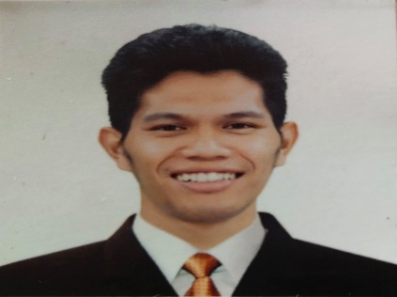**DHAVECRIS A. AFABLE**

**2251 Vision St. Sta. Cruz, Manila**

**#09493632486**

[**criselbafa1993@gmail.com**](mailto:criselbafa1993@gmail.com)

# CAREER OBJECTIVES

***To obtain a position where I could effectively apply my skills and knowledge I’ve learned and to given an opportunity to work productively and accurately in your company.***

# PERSONAL INFORMATION

**Date of birth:** Dec 24, 1993 **Place of birth:** Manila

**Civil Status:** Single

**Height:** 5’11

**Weight:** 63 Kg

**Religion:** Catholic

# EDUCATIONAL ATTAINMENT

## Technical Education and Skills Development Authority

**Food and Beverage Service**

**School Year:** 2018

**NCII Holder**

## Secondary Education

**School:** Esteban Abada High School

**School Year:** 2006-2011

## Elementary School

**School:** Juan Sumulong Elementary School

**School Year:** 1999-2006

# SPECIAL SKILLS

* Ability to work multitasking.
* Trustworthy.
* Willing to be trained.
* Strong communication skills.
* Excellent ability to adapt to difficult situations.
* Detail oriented

**WORKING EXPERIENCE**

# Genki Shushi- Ayala Malls Manila Bay

(2019-2020 Kitchen Staff

# GMA7 Employee’sMulti-Purpose Cooperative

(2017-2019) Service Crew

# Pares Retiro

(2014-2015) Server/Stock Man / Purchaser

# K.Cunanan Catering Service

(2012-2013) Waiter

# Classique Fondue Catering

(2011-2012) Waiter

# CHARACTER REFERENCES

**Ian Gatmaitan Robin Contreras**

*(CGI Philippines (café aguatica)* **0915 700 1417 09750095806**

*I hereby certify that the above information is true and correct to the best of my knowledge and belief.*

**DHAVECRIS A. AFABLE**

**APPLICANT**