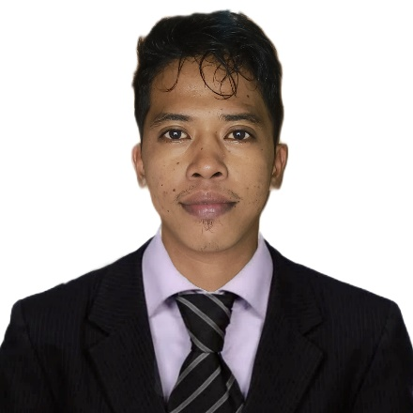

**ZAÑO, ARCHIEMEDES B.  
Address**: Poblacion, Puerto Galera Oriental Mindoro  
**Email Address**: [zanoarchie8@gmail.com](mailto:zanoarchie8@gmail.com)  
**Contact no**: 09942450916

**Objectives:**To obtain a position in a successful company offering an exceptional career growth opportunity where I can utilize my skills and abilities.

**Qualification:**\*Computer literate (MS Word, excel, PowerPoint MS Outlook)  
*Quality writing and communication skills.  
*Ability to maintain a high level of confidentially.  
* High level of responsibility and fast learning traits.  
*Capacity to multi-task under pressure.  
*Highly trained writing abilities.

**Personal Information:**Gender : Male  
Age : 25  
Birthdate : April 9, 1998  
Height : 163 km  
Weight : 57 kg  
Status : Single  
Citizenship : Filipino  
Religion : Catholic

**Educational Background:**

* **TERTIARY**

STI COLLEGE GLOBAL CITY

Bachelor of Science in Business Management  
2015-2016

* **SECONDARY**

PUERTO GALERA NATIONAL HIGH SCHOOL

2011-2015

* **PRIMARY**

PUERTO GALERA CENTRAL SCHOOL

2005-2011

**­­­­­­­­­­­­­Experience:  
  
All Around (Housekeeping, Service Crew, Assist Cook, Receptionist)  
(March 2016 – April 2017)  
DUTIES AND RESPONSIBILITIES   
\***Answer and transfer telephone calls or take messages.*Schedule appointments and receive customers or visitors.* Provide general information to staff, clients, or the public.*Keeping facilities and common areas clean and maintained.*Vacuuming, sweeping, and mopping floors.*Checking rooms for supplies and restocking items like toilet paper or soap.* Maintaining regular communication with other housekeeper attendant and management.*Checking equipment to ensure that it is in proper working order, letting the maintenance team know if there might be a problem.*Backing up other crew members in their jobs, assist in any area to ensure that the food is being prepared, packaged and delivered to customer in a timely manner.*Undertake cleaning and washing up as directed in the kitchen and dining areas*Refill and replace sauces, condiments and consumables.

**LABORATORY ENCODER**  
**(Sept 2017- Sept 2019 )**  
**\***Encode patient records and patient result s in the clinic information system.  
*Extracting relevant information from patient record.  
*Receive and review patient records and supporting documentation for accuracy.  
* Timely coordinate and communication with the other clinic staff on records/ results that is  
insufficient or unclear.  
*Informing supervisor of issues with equipment and computer program.  
*Ensuring documents are grammatically correct and free typing errors.  
*Release patient results according to patient’s dispatch request**.**

**HELPER**   
**(SEPT 2019- MARCH 2020)**  
**\***Serves customers by selling products and meeting customer needs.  
*Provides historical records by maintaining records on are and customer sales.  
*Contribute to team effort by accomplishing related results as needed.  
*Resolve customer complaints by investing problems, developing solutions, preparing reports, and making recommendations to management.  
*Monitors competition by gathering current marketplace information on pricing product, new products delivery schedules, and merchandising techniques.

**OPERATOR OF GO KART   
(March 17, 2021- Jan 15, 2024)  
\***Provide excellent customer service to all speed factory indoor karting visitors.*Coordinate track operations, monitor races safe operation of karts, and provide exceptional racing experience for guest.*Maintain track cleanliness at all times.* Communication with customers and coworkers in a professional and friendly manners.*Make sure all customers know and understand go kart rules.

**CHARACTER REFFERENCE:**

**NAME : EFREN EVANGELISTA  
OCCUPATION : OWNER  
COMPANY : HOLLYWOOD PALM BEACH RESORT**

**NAME : OSCAR EVANGELISTA  
OCCUPATION : OWNER  
COMPANY : URGENT CARE CLINIC AND DIAGNOSTIC CENTER**

**NAME : HERMAN LUCIEN ALBERT VAN LIERDE  
OCCUPATION : OWNER  
COMPANY : EXTREME SPORT/ 09175528114**

***I HEREBY CERTIFY THAT THE ABOVE INFORMATION IS TRUE AND CORRECT TO THE BEST OF MY KNOWLEDGE AND BELIEF.***

**ARCHIEMEDES B. ZAÑO**

**APPLICANT**