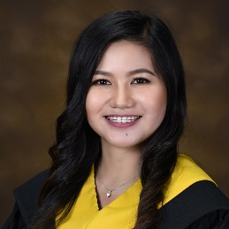

**CONTACT**

Quezon City, Metro Manila 1117

09173272589

[domingojourgette@gmail.com](mailto:domingojourgette@gmail.com)

**SUMMARY**

* Knowledgeable Administrative Assistant dedicated to improving procedures for file movements, eliminating unnecessary storage and maintaining secure information.

Verifies documents, researches problems and implements effective solutions.

* Accurate, assertive and adaptable Personal Assistant who can effectively multi-task in challenging

situations and meet critical deadlines.

**SKILLS**

* Knowledge of Microsoft Office
* Resourcefulness
* Problem-Solving
* Communication Skills
* Planning
* Organizing
* Marketing
* Documentation
* Campaign Management

Jourgette Domingo

# EXPERIENCE



**Political Affais Assistant III** House of Representatives - Quezon City, Philippines

07/2019 – 09/2024

* Collaborated with team members to achieve target results.
* Handled national and international travel arrangements, ensuring accuracy of relevant information and booking details.
* Took detailed minutes in meetings, circulating information and relevant actions and chasing up accordingly.
* Diarised and supported delivery of meetings, preparing agendas, relevant paperwork and booking required equipment.
* Handled incoming calls and emails with warmth and professionalism, redirecting enquiries to relevant staff.
* Provided effective meeting support by preparing agendas and taking minutes.
* Supervised executive calendars while supporting administrative team to facilitate smooth operational flow.
* Served as executive assistant to Congressman.
* Scheduled and planned meetings and conferences to streamline business operations.
* Updated client correspondence files and noted additions in file index.
* Greeted visitors and appropriately directed to designated areas.
* Performed administrative tasks, document management and report development for inter-departmental use.
* Answered phones and performed clerical office functions to address queries, concerns and issues, escalating complaints to management.
* Booked and coordinated equipment maintenance to meet operational needs.
* Booked and paid for business travel and accommodation, communicating booking information to relevant staff.
* Safeguarded sensitive and confidential data in compliance with security best practices.
* Received and responded to high-volume correspondence via email and live chat.

# EDUCATION

**Bachelor of Business Administration: Marketing Management**

**New Era University** - Quezon City, 2019